# JavaScript for Front-End – DOM Manipulations

Your task is to write the Front-End part of an application which renders information into HTML.

There are a few simple tasks. Those little tasks will ultimately combine into the functionality you need for the application itself.

## Rendering Data in HTML – 100 pts

In order for the HTML to look tidy and well formed, CSS needs to be applied, which suggests some specific element hierarchy and classes. Check the template and make sure your function renders the object correctly. You can see input and output below.

Create your functions for this task inside the jquery-data.js file, and implement them so that they render the data inside the jquery-data.html file.

### Render Header in HTML – 50 pts

#### Input

|  |
| --- |
| jquery-data.html |
| <!DOCTYPE **html**> <**html**> <**head**>  <**meta charset="utf-8"**>  <**link rel="stylesheet" type="text/css" href="code-mesh-conference.css"**>  <**title**>Conference Landing Page</**title**> </**head**> <**body**> <**header**>  <**nav**>    </**nav**>  <**div id="center"**>    </**div**>  <**section class="header-section"**>    </**section**> </**header**>  </**body**> </**html**> |
|  |

#### Output

|  |
| --- |
| jquery-data.html |
| <!DOCTYPE **html**> <**html**> <**head**>  <**meta charset="utf-8"**>  <**link rel="stylesheet" type="text/css" href="code-mesh-conference.css"**>  <**title**>Conference Landing Page</**title**> </**head**> <**body**> <**header**>  <**nav**>  <**span id="logo"**>Code Mesh</**span**>  <**ul**>  <**li class="list-item"**><**a href="#"**>speakers</**a**></**li**>  <**li class="list-item"**><**a href="#"**>schedule</**a**></**li**>  <**li class="list-item"**><**a href="#"**>workshops</**a**></**li**>  <**li class="list-item"**><**a href="#"**>login</**a**></**li**>  </**ul**>  </**nav**>  <**div id="center"**>  <**p**>The urge for coding innovations is the same as the urge to go on living</**p**>  <**i class="fa fa-play-circle fa-4x"**></**i**>  </**div**>  <**section class="header-section"**>  <**article**>  <**i class="fa fa-code fa-2x" aria-hidden="true"**></**i**>  <**p**>  CodeMesh returns to Sofia 11th вЂ“ 12th May, 2017. We promise you the very best developer content and  awesome experiences.  </**p**>  </**article**>  <**article**>  <**i class="fa fa-area-chart fa-2x" aria-hidden="true"**></**i**>  <**p**>  This year, CodeMesh is welcoming top speakers not only from the country, but Europe and even USA!  </**p**>  </**article**>  <**article**>  <**i class="fa fa-diamond fa-2x" aria-hidden="true"**></**i**>  <**p**>  We're also going to have a much bigger and cooler networking event after the conference!  </**p**>  </**article**>  <**article**>  <**i class="fa fa-cube fa-2x" aria-hidden="true"**></**i**>  <**p**>  Join us and immerse yourself in all the different tracks and topics available to out attendees!  </**p**>  </**article**>  </**section**> </**header**>  </**body**> </**html**> |

If you do everything correctly, you should see this:

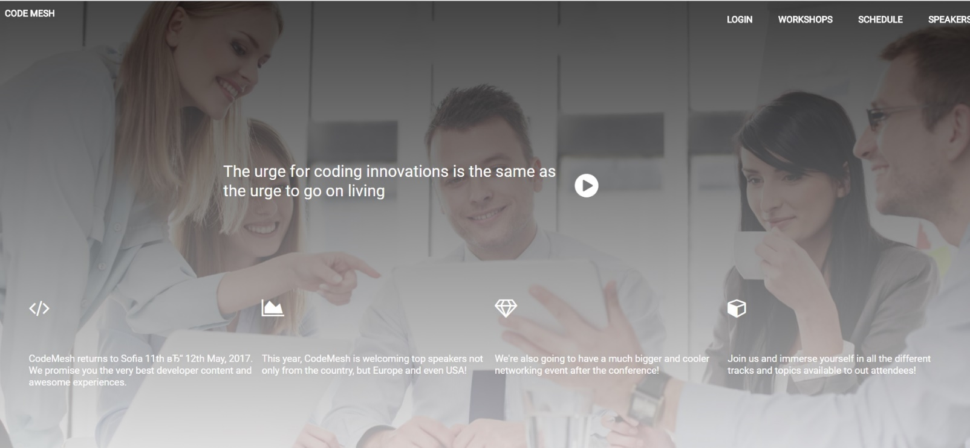

### Render Main In HTML – 50 pts

Render the date of single element like following:

#### Input

|  |
| --- |
| jquery-data.html |
| <!DOCTYPE **html**> <**html**> <**head**>  <**meta charset="utf-8"**>  <**link rel="stylesheet" type="text/css" href="code-mesh-conference.css"**>  <**title**>Conference Landing Page</**title**> </**head**> <**body**> <**header**>  <**nav**>  <**span id="logo"**>Code Mesh</**span**>  <**ul**>  <**li class="list-item"**><**a href="#"**>speakers</**a**></**li**>  <**li class="list-item"**><**a href="#"**>schedule</**a**></**li**>  <**li class="list-item"**><**a href="#"**>workshops</**a**></**li**>  <**li class="list-item"**><**a href="#"**>login</**a**></**li**>  </**ul**>  </**nav**>  <**div id="center"**>  <**p**>The urge for coding innovations is the same as the urge to go on living</**p**>  <**i class="fa fa-play-circle fa-4x"**></**i**>  </**div**>  <**section class="header-section"**>  <**article**>  <**i class="fa fa-code fa-2x" aria-hidden="true"**></**i**>  <**p**>  CodeMesh returns to Sofia 11th вЂ“ 12th May, 2017. We promise you the very best developer content and  awesome experiences.  </**p**>  </**article**>  <**article**>  <**i class="fa fa-area-chart fa-2x" aria-hidden="true"**></**i**>  <**p**>  This year, CodeMesh is welcoming top speakers not only from the country, but Europe and even USA!  </**p**>  </**article**>  <**article**>  <**i class="fa fa-diamond fa-2x" aria-hidden="true"**></**i**>  <**p**>  We're also going to have a much bigger and cooler networking event after the conference!  </**p**>  </**article**>  <**article**>  <**i class="fa fa-cube fa-2x" aria-hidden="true"**></**i**>  <**p**>  Join us and immerse yourself in all the different tracks and topics available to out attendees!  </**p**>  </**article**>  </**section**> </**header**> <**main**>  <**section class="left"**>   </**section**>  <**section class="center"**>   </**section**>   <**section class="schedule"**>   </**section**>  <**section class="position-right"**>   </**section**> </**main**></**body**></**html**> |

#### Output

|  |
| --- |
| jquery-data.html |
| <!DOCTYPE **html**> <**html**> <**head**>  <**meta charset="utf-8"**>  <**link rel="stylesheet" type="text/css" href="code-mesh-conference.css"**>  <**title**>Conference Landing Page</**title**> </**head**> <**body**> <**header**>  <**nav**>   </**nav**>  <**div id="center"**>   </**div**>  <**section class="header-section"**>   </**section**> </**header**> <**main**>  <**section class="left"**>  <**p**>  "I think it's really important to think outside  of the box when you're coding"  </**p**>  <**span class="MarcNewson"**>words by marc newson</**span**>  </**section**>  <**section class="center"**>  <**p**>  When youвЂ™re busy leading a team, coding and maintaining  standards, how do you find the time to stay ahead of  new technologies and develop yourself as a technical lead?  Software continues to transform the world in remarkable  ways and developers are at the center of it. At CodeMesh 2017  we invite you to join us in Sofia to learn about  latest new technologies and exciting plans on the horizon.  As always, CodeMesh is filled with strong technical sessions  as well as opportunities to meet and learn from others in  the industry. WeвЂ™ll make sure the schedule is filled with  solid content, and will strive to deliver some fun surprises along the way.  </**p**>  <**span class="bottom"**>  You can code and create, and build the most wonderful place in the world.  </**span**>  </**section**>  <**img id="right-img" src="img/intro-img.png"**/>  <**div id="orange"**></**div**>   <**section class="schedule"**>  <**h2**>Schedule: Grab some coffee & donuts and take a seat</**h2**>  <**div class="registration"**>  <**i class="fa fa-address-book-o orange-icon" aria-hidden="true"**></**i**>  <**span class="time"**>09:00 - 10:00 AM</**span**>  <**p**>registration</**p**>  </**div**>  <**div class="mic"**>  <**i class="fa fa-microphone orange-icon" aria-hidden="true"**></**i**>  <**span class="time"**>11:00 - 12:00 AM</**span**>  <**p**>the future of creative computing</**p**>  </**div**>  <**div class="lunch"**>  <**i class="fa fa-cutlery orange-icon" aria-hidden="true"**></**i**>  <**span class="time"**>12:00 - 13:00 PM</**span**>  <**p**>lunch break</**p**>  </**div**>  </**section**>  <**section class="position-right"**>  <**div class="linux"**>  <**i class="fa fa-microphone orange-icon" aria-hidden="true"**></**i**>  <**span class="time"**>13:00 - 14:00 AM</**span**>  <**p**>linux for developers</**p**>  </**div**>  <**div class="wonderful"**>  <**i class="fa fa-microphone orange-icon" aria-hidden="true"**></**i**>  <**span class="time"**>14:00 - 15:00 AM</**span**>  <**p**>the wonderful world of IOT</**p**>  </**div**>  <**div class="do-we-need"**>  <**i class="fa fa-microphone orange-icon" aria-hidden="true"**></**i**>  <**span class="time"**>15:00 - 16:00 AM</**span**>  <**p**>do we need to read coding books?</**p**>  </**div**>  </**section**>  </**main**></**body**></**html**> |
|  |

If you do everything correctly, you should see this:

